Water Fountain

Subject:  Related Subjects: | Grade Level(s):  Length of Lesson: | Type: Inquiry / Design / Project  Keywords: Pressure, vacuum, force, gravity, motion, impeller, basin, centrifugal, centripetal, velocity, speed, volute, kinetic energy

Lesson Overview
Use this section to describe at a high level what the lesson is. Should be no more than 3-4 lines.

Lesson Focus
What is the central question or phenomenon being investigated? What problem are they trying to solve?

Lesson Objective(s) | - Students will create motor circuit  - Students will create water tight container  - Students will construct working water fountain

Lesson Timing

5 minutes | Introduce the Lesson
30 minutes | ...

Materials | - –Water bottle  - –2 water bottle caps  - –Film canister  - –¼” OD plastic tubing  - –Glue gun  - –Glue stick  - –Foam board  - –AA battery holder  - –2 AA batteries  - –1.5 V motor  - –Toggle switch  - –Insulated wires  - –Wire cutters  - –Jumbo paper clip  - –Drill  - –Pencil  - –Sandpaper  - –¼” drill bit
Instructor Prep | - Step 1
Related Resources | - List related lessons/ppts etc available from USC or outside, trusted orgs

Lesson Plan

Introduction

Water in the water fountains starts in the basin, goes through a drain and is pushed up through a tube back into the basin. Gravity causes the water to fall through the drain. A centrifugal pump is what forces the water through the tube. Centrifugal force is a common term for the force caused by spinning. However, it is not a real force. To understand this we must understand a few other principles

Anything that moves goes from one place to another in a certain time. We call this speed if goes in one direction. When something moves at a certain speed but changes direction we have to come up with another name. This is called velocity. Velocity is speed with direction. If you are going 10 miles per hour (mph) and you make a left turn but keep going 10mph, your speed is the same but your velocity has changed. If you are going 10mph and you go faster at 15mph, your velocity has also changed (and so has your speed). When ever you change your velocity it is called accelerating. This is why the gas pedal in a car is sometimes called an accelerator. If you speed up or slow down, you are accelerating (slowing down is still accelerating but backwards, we also call this decelerating). If you change direction and speed up, slow down or stay the same speed, you still are accelerating.

When an object moves, a force has to cause it to go. The force can be from inside or outside. You can make a car go by pressing the accelerator (inside) or by pushing (outside). If the object is sitting still, the force has to be strong enough to make the object move. The object “resists” moving. This is called Newton’s First law. The same happens if an object is moving. To stop it or change its direction, you need another force. If the object is moving in a circle, a force has to push it to keep turning toward the center otherwise it would go straight. This force is called centripetal force. Think of it as a turning force. Since the direction is of the object is changing, its velocity is changing.

Centrifugal force goes back to Newton’s first law. The object is trying to go straight and centripetal acceleration causes it to turn. The object still wants to go straight and resists turning. This resisting is called inertia and what most people mean when they say centrifugal force. It is actually the object itself trying to stay straight when the turning force makes it turn.

Back to centrifugal pumps. The pumps purpose is to convert energy of a mover (an electric motor in our case) first into velocity and then into pressure. The changes occur by from two main parts of the pump, the impeller and the volute. The impeller is the rotating part that converts driver energy into the kinetic energy. The volute is the basin where velocity is converted into pressure. The key idea is that the energy created by the “centrifugal force” is kinetic energy. The amount of energy given to the liquid comes from velocity at the tip of the impeller. The faster the impeller revolves or the bigger the impeller is, then the higher will be the velocity of the liquid at the tip and the greater the energy given to the liquid.

The kinetic energy of the liquid is resisted is created by the volute (basin) that holds the liquid and slows it down. In the tube, the liquid further decelerates and its velocity is converted to pressure according to Bernoulli’s principle. Bernoulli’s principle states the pressure of a liquid changes opposite to changes in its velocity. An increase in velocity produces a decrease in pressure and vice a decrease in velocity increases an increase in pressure. If you are walking in a crowd really fast, no one will be pushing your forward (very little pressure behind you). However, if you walk in a crowd of people and you slow down, the people behind you will push you forward (lots of pressure and probably bad words).

In our water fountain, initially the water flows through a drain (the hole in the upper bottle cap) by the force of gravity into the basin (the lower bottle cap).The impeller (glue stick piece) pushes the water in a circle. The water closer to the impeller moves faster than the water near the walls of the cap. This means there is lower pressure in the middle of the bottle. More water is then sucked down through the drain in the bottle cap above the impeller. This water is then pushed to the wall of the bottle where it slows down and builds pressure. The pressured water is then pushed through the tube. The pressure at the other end of the tube is very low. The water then moves from the high pressure area inside the cap to the low pressure area outside of the tube. Although the tube has lower pressure, the force from the water pressure has become large enough to overcome the force of gravity for the water to flow up the tube. This may take a while which is why when we build the fountain; we will hold the tube down first to get the water flowing so its inertia will keep it going when we lift the tube and attach it to the water bottle.

Procedure
- –Cut top off of bottle where bottle begins to curve
- –Remove bottle cap and drill hole with ¼” drill bit
- –Sand top of bottle cap.
- –Glue motor to bottom of bottle cap (inserting motor stem into hole)

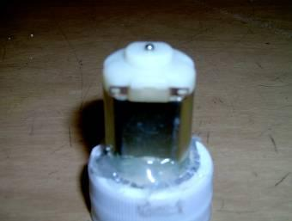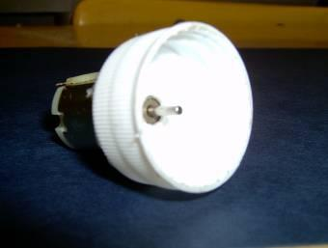
- –Using pencil, poke two holes (two fingers apart) in the bottom of film canister.
- –Cut and strip 1-6” piece of insulated wire
- –Strip both wires of battery holder.
- –Insert one end of stripped wire through one hole in canister (from outside to inside) and connect to one lead of motor (motor will be able to sit inside of the canister).
- –Connect other end of wire to either outer lead of switch outside of canister.
- –Connect one wire of battery holder through other hole in canister (from outside to inside) to second lead of motor.
- –Connect the other battery holder wire to middle lead of switch.

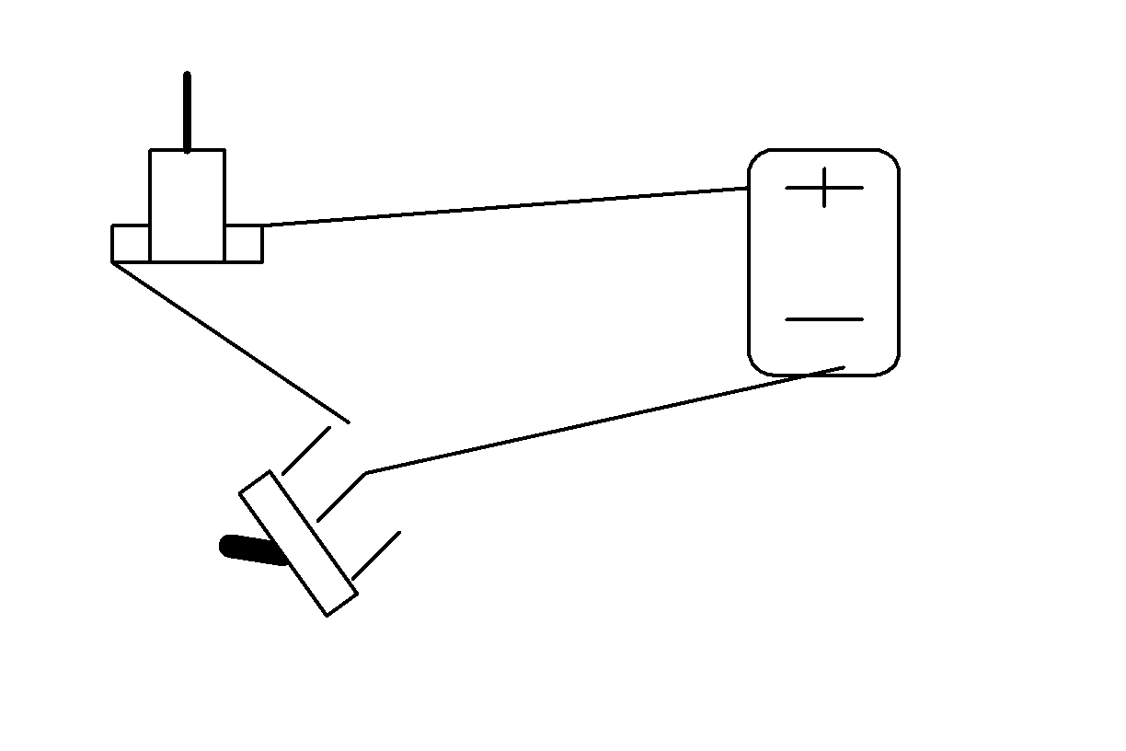
- –Test circuit with batteries.
- –Cut a piece of glue stick ¼” x 1/8” x 1/8”, this will be your impeller
- –Push stem of motor through impeller.
- –Screw cap/motor fixture to bottle top.
- –Drill hole using ¼” drill bit through the cap and bottle.
- –Insert tube through hole (make sure it doesn’t hit impeller) and glue in place.

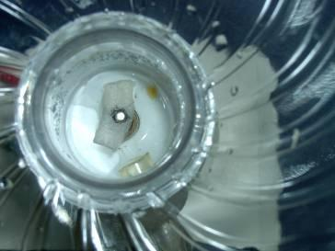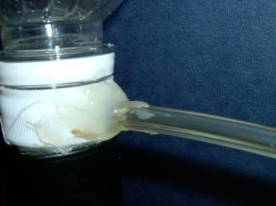

- –Cut a small grove in top of film canister so that the bottle top assembly can fit evenly and insert it.
- –Cut 2” by 6” strip of foam board.
- –Glue canister, battery holder and switch to foam board.
- –Poke pencil hole into 2nd bottle cap.
- –Glue bottle cap open side facing up over opening of bottle top assembly, covering the impeller.

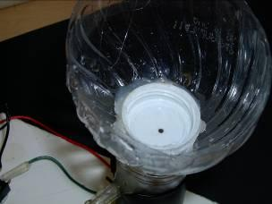

- –Insert free end of tube through paper clip

- 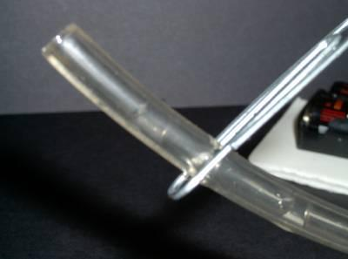
- –Add water to the fountain
- –Turn switch to start motor and impeller
- –Hold the tube down allowing water to run out (into a cup) to start the water flow for the fountain.

- 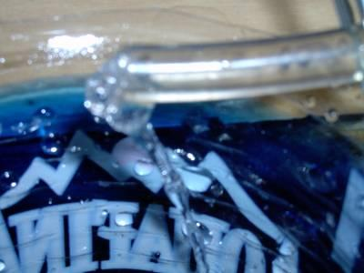
- –After the water flows (about 45 seconds), attach the tube to the side of the fountain (be careful of water spillage)

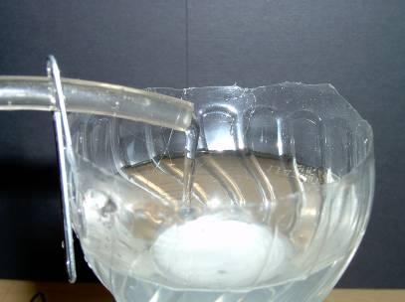
- –Your fountain is now complete

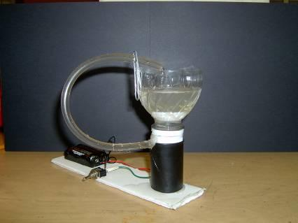

Wrap-up
End the lesson with some final discussions about what students designed/discovered. Connect their activity back to the focus question/problem, real world examples, and STEM careers.

Also include notes about any special cleanup considerations

Lesson Background for Teachers

Suggested Real-World STEM Connections
- List possible related Role Models in STEM (with details and links to more reading). Give suggestions for examples of scientists/engineers who are from underrepresented groups in STEM in related careers.
- List related real-world engineering problems and examples

Lesson Variations and Options
Include descriptions of alternative methods or ways to present things.

Explanation
Describe the background concepts and explanations behind the lesson. This can be more in depth than a teacher/instructor would actually share with students.

Key Concepts and Vocabulary
- Word 1: Grade Appropriate Definition
- Word 2: Grade Appropriate Definition

Safety Notes
- Safety instruction

